State of Michigan

OBRA Automation suite

Workflow 10

CMH Coordinator Level I Workflow

**Workflows with screenshots:**

This workflow deals with the changes to the 4 day and 14 day CMH functions. Need to add the additional options on the “3877-78 Detail” screen.

Login as CMH Coordinator. Navigate to the 14 day queue.

Land on the 3877-78 Detail page. Scroll down to the “Evaluation Status” Section.

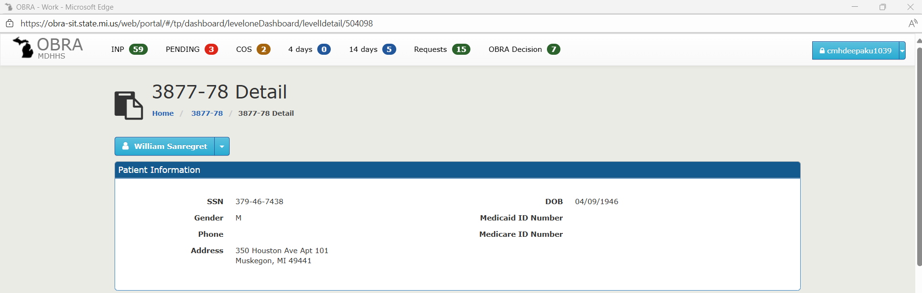

In the existing workflow, the below options are already covered. Need to add the last “Other” option too in the Automation suite.

* Significant Mental Illness (and/or) ID/DD, RC
* Not Seriously Mentally Ill (NSMI)
* Planned Discharge
* Readmit/Transfer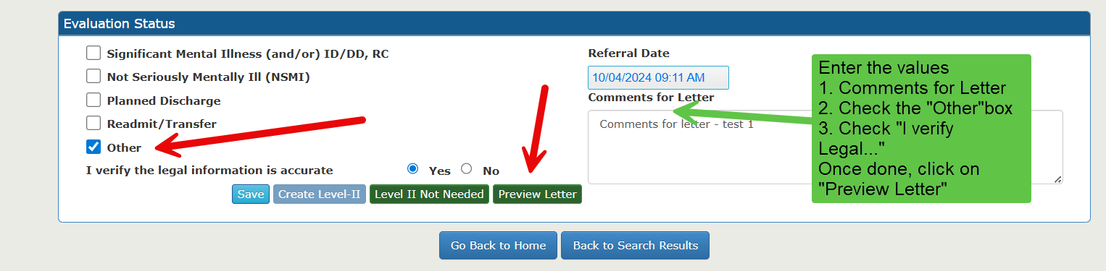

Letter opens up in new window. Capture the PDF.

Go back to the Evaluation Status section.

Click on “Level II Not Needed”

Scroll up, make sure that the 14 days queue count is reduced, the Level Status is changed to “Not Needed”.

Under Consumer name dropdown, click on “Letter History”

Click on Consumer Name to view the letter again.

After this is done,

Login as Facility User for the facility in the assignment (part of existing regression flow)

Navigate to “OBRA Decision” queue.

Find the record

Click “Generate Letter”

The record will go away from the “OBRA Decision” queue.

Testing the “Reset 3877-78 Status” Scenario:

Login as CMH Coordinator. Navigate to the 14 day queue.

Click on the record and land on 3877-78 Detail Page.

Scroll down to the “Evaluation Status” Section.

Select “Not Seriously Mentally Ill (NSMI)” Option, then select “I verify Legal Information…”, enter letter comments and then click on Preview letter.

Letter opens up in new window.

Navigate back to 3877-78 Detail screen Evaluation Status section and click on “Level II Not Needed”.

Once done, this is the screen.

Click on”Reset 3877-78 Status”

All the values in the section will be cleared off. A pop up window appears. Click OK.

